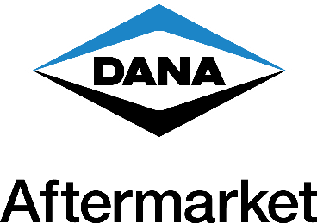

MEDIA ALERT
Jan. 12, 2023

Dana to Introduce New Technology, Innovative Products at HDAW

Visit Dana at Booth 709

Dana Incorporated will showcase new and innovative products during Heavy Duty Aftermarket Week (HDAW) at the Gaylord Texan Resort held Jan. 16-19 in Grapevine, Texas. To help kick off the event, Dana will sponsor the All-Industry Welcome Reception on Jan. 16 in the third-floor foyer at 5:30 p.m.

Dana is set to unveil the groundbreaking Spicer® EZ-ID digital tool during HDAW. Visitors to booth 709 can see this intuitive, step-by-step technology in action on DanaAftermarket.com. EZ-ID is an easy-to-use visual pathway that offers quick identification of driveline assembly part numbers that are missing product tags or other identifiers.

At booth 709, Dana will feature Victor Reinz® Reinzosil® room-temperature vulcanizing (RTV) silicone, a permanently elastic, universal silicone sealing compound, providing superior resistance to fluids and extreme temperatures. Newly available in three sizes, 70 milliliter tubes, 20 milliliter cans and 310 milliliter cartridge tubes for larger jobs, Reinzosil can take the place of over a dozen RTV varieties, is safe for all sensors, and is ideal for use on two-dimensional flat surfaces where there is a sealing gap.

Also on display at HDAW will be the Dana-customized Ford® Bronco® upgraded with the Ultimate Dana 60™ rear semi-float axle and Ultimate Dana 44™ front drive unit and the Jeep® Wrangler® featuring the Ultimate Dana 60™ front axle and Dana 80™ rear axle.

The Dana team will be available for one-on-one meetings and demonstrations of the industry-leading DanaAftermarket.com e-commerce platform. For onsite inquiries at HDAW, please contact Beth Mooney at (419) 309-9067. To learn more about HDAW, visit www.hdaw.org.

# # #

